**MANMEET KAUR**

**Ques1.**

Part (a): Find the Average Velocity Over the Given Time Intervals

The height function is given by:

y(t) = 10*t - 1.86*t^2

The formula for the average velocity over an interval [t1, t2] is:

Average Velocity = (y(t2) - y(t1)) / (t2 - t1)

(i) Time interval [1, 2]

y(1) = 10*1 - 1.86*1^2 = 10 - 1.86 = 8.14

y(2) = 10*2 - 1.86*2^2 = 20 - 7.44 = 12.56

Now calculate the average velocity:

Average Velocity = (12.56 - 8.14) / (2 - 1) = 4.42 m/s

(ii) Time interval [1, 1.5]

y(1.5) = 10*1.5 - 1.86*1.5^2 = 15 - 4.185 = 10.815

Now calculate the average velocity:

Average Velocity = (10.815 - 8.14) / (1.5 - 1) = 2.675 / 0.5 = 5.35 m/s

(iii) Time interval [1, 1.1]

y(1.1) = 10*1.1 - 1.86*1.1^2 = 11 - 2.2466 = 8.7534

Now calculate the average velocity:

Average Velocity = (8.7534 - 8.14) / (1.1 - 1) = 0.6134 / 0.1 = 6.134 m/s

(iv) Time interval [1, 1.01]

y(1.01) = 10*1.01 - 1.86*1.01^2 = 10.1 - 1.890186 = 8.209814

Now calculate the average velocity:

Average Velocity = (8.209814 - 8.14) / (1.01 - 1) = 0.069814 / 0.01 = 6.9814 m/s

(v) Time interval [1, 1.001]

y(1.001) = 10*1.001 - 1.86*1.001^2 = 10.01 - 1.860186 = 8.149814

Now calculate the average velocity:

Average Velocity = (8.149814 - 8.14) / (1.001 - 1) = 0.009814 / 0.001 = 9.814 m/s

Part (b): Estimate the Instantaneous Velocity When t = 1

To estimate the instantaneous velocity at t = 1, use small intervals, as in part (a), and calculate the average velocity. The instantaneous velocity is the limit of the average velocities as the interval approaches zero.

The formula to estimate the instantaneous velocity is:

v(1) ≈ (y(1 + Δt) - y(1)) / Δt

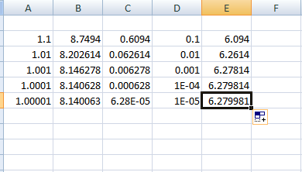

As the time interval Δt becomes smaller, the average velocity approaches approximately 6.28m/s, which is the estimate of the instantaneous velocity at t=1

**Ques 2**

The displacement (in centimeters) of a particle moving along a straight line is given by the equation:

**s(t) = 2*sin(π*t) + 3*cos(π*t)**

where t is measured in seconds.

Part (a): Find the Average Velocity Over the Given Time Intervals

The formula for average velocity over an interval [t1, t2] is:

Average Velocity = (s(t2) - s(t1)) / (t2 - t1)

(i) Time interval [1, 2]

s(1) = 2*sin(π*1) + 3*cos(π*1) = 2*0 + 3*(-1) = -3

s(2) = 2*sin(π*2) + 3*cos(π*2) = 2*0 + 3*1 = 3

Now calculate the average velocity:

Average Velocity = (3 - (-3)) / (2 - 1) = 6 / 1 = 6 cm/s

(ii) Time interval [1, 1.1]

s(1) = 2*sin(π*1) + 3*cos(π*1) = -3

s(1.1) = 2*sin(π*1.1) + 3*cos(π*1.1) = 2*sin(1.1π) + 3*cos(1.1π) ≈ -3.5846

Now calculate the average velocity:

Average Velocity = (-3.5846 - (-3)) / (1.1 - 1) ≈ (-0.5846) / 0.1 = -5.846 cm/s

(iii) Time interval [1, 1.01]

s(1) = -3

s(1.01) = 2*sin(π*1.01) + 3*cos(π*1.01) = 2*sin(1.01π) + 3*cos(1.01π) ≈ -3.05799

Now calculate the average velocity:

Average Velocity = (-3.05799 - (-3)) / (1.01 - 1) ≈ (-0.05799) / 0.01 = -5.799 cm/s

(iv) Time interval [1, 1.001]

s(1) = -3

s(1.001) = 2*sin(π*1.001) + 3*cos(π*1.001) = 2*sin(1.001π) + 3*cos(1.001π) ≈ -3.00579

Now calculate the average velocity:

Average Velocity = (-3.00579 - (-3)) / (1.001 - 1) ≈ (-0.00579) / 0.001 = -5.79 cm/s

Part b :

As Δt gets smaller, the average velocity approaches approximately **-6.283 cm/s**, which is the estimate for the instantaneous velocity at t=1.

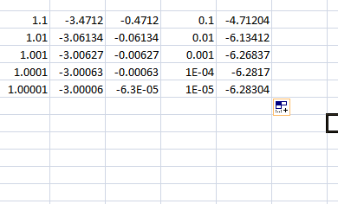

**Ques 3**

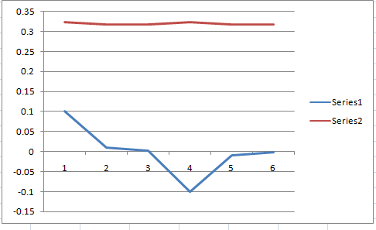

The estimated value of the limit

lim⁡x→0

is **1.00** when rounded to two decimal places.

This estimation can be confirmed through both the graph of the function f(x) and by evaluating the function for values of x approaching 0, which should yield values that closely approach 1.

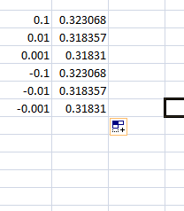

**Ques 4**

To estimate the limit, let's calculate the function  
(1 + x)^(1/x) for values of x approaching 0 from both the positive and negative sides:

For x = 0.1,  
(1 + 0.1)^(1/0.1) = 2.59374

For x = 0.01,  
(1 + 0.01)^(1/0.01) = 2.70481

For x = 0.001,  
(1 + 0.001)^(1/0.001) = 2.71692

For x = -0.001,  
(1 - 0.001)^(1/-0.001) = 2.71964

As x → 0, the value converges to e = 2.71828.

This value looks familiar because it is Euler's number, denoted e, which is approximately 2.71828. Euler's number plays a central role in calculus, especially in the context of limits, exponentials, and logarithms.

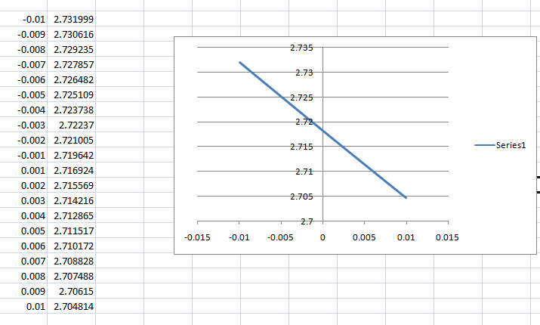

• As x approaches 0, the graph converges to Euler’s number e≈2.71828

• For negative xvalues (e.g., x=−0.001) the function dips slightly below e, but as x approaches 0 from the left, the values rise toward e

• For positive x values (e.g., x=0.001), the function quickly approaches e.

**Ques 5**

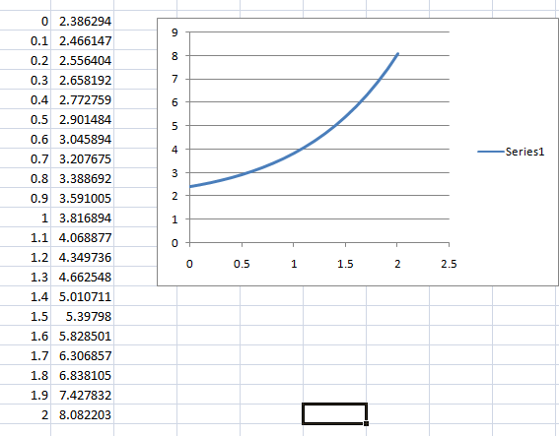

**Is the Graph Accurate?**

The graph might look a bit distorted near x = 4. This is because the function ln∣x−4∣ has a singularity at x = 4. The logarithmic term goes to negative infinity as x approaches 4 from the left and increases as x approaches 4 from the right. Excel might not represent this behavior well because of how close the values get to the singularity, and it might generate an error at x = 4.

**(b) How to Get a Better Representation of f(x):**

1. **Refine the Range**: Use smaller step sizes near x = 4 to better capture the sharp behavior around the singularity. For instance, you can use smaller increments around values close to 4, such as 3.9, 3.95, 3.99, 4.01, 4.05, etc.
2. **Exclude the Point at x=4**: Since ln(0) is undefined, exclude x = 4 from the data set. You can replace it with very close points (like 3.999 and 4.001) to show the steep change near x = 4.
3. **Plot Points on Both Sides of x=4**: Ensure that your graph captures behavior as x approaches 4 from both sides. For values less than and greater than 4, choose x-values carefully to see how the function behaves around the singularity.

**Ques6**

This expression can be simplified using algebra:

x3−1x−1=(x−1)(x2+x+1)

The (x−1) terms cancel out, leaving:

x^2 + x + 1

So, the limit 1x→1 becomes:

1^2 + 1 + 1 = 3

We can now confirm this using Excel and numerical approximation by evaluating the function for values of x close to 1.

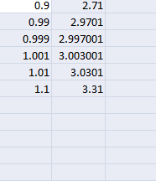

**(b) Determining the Proximity to 1 for a Distance of 0.5 from the Limit**

The limit is 3. To find how close x needs to be to 1 such that the function is within 0.5 of 3, we need to find x such that:

∣x3−1x−1−3∣<0.5

This means the function's value must lie between 2.5 and 3.5. You can adjust the values of x in your Excel sheet until the function value is within this range.